**Team name: SEM_ALPHA**

**PS ID: SS42**

**High-level design of the application**

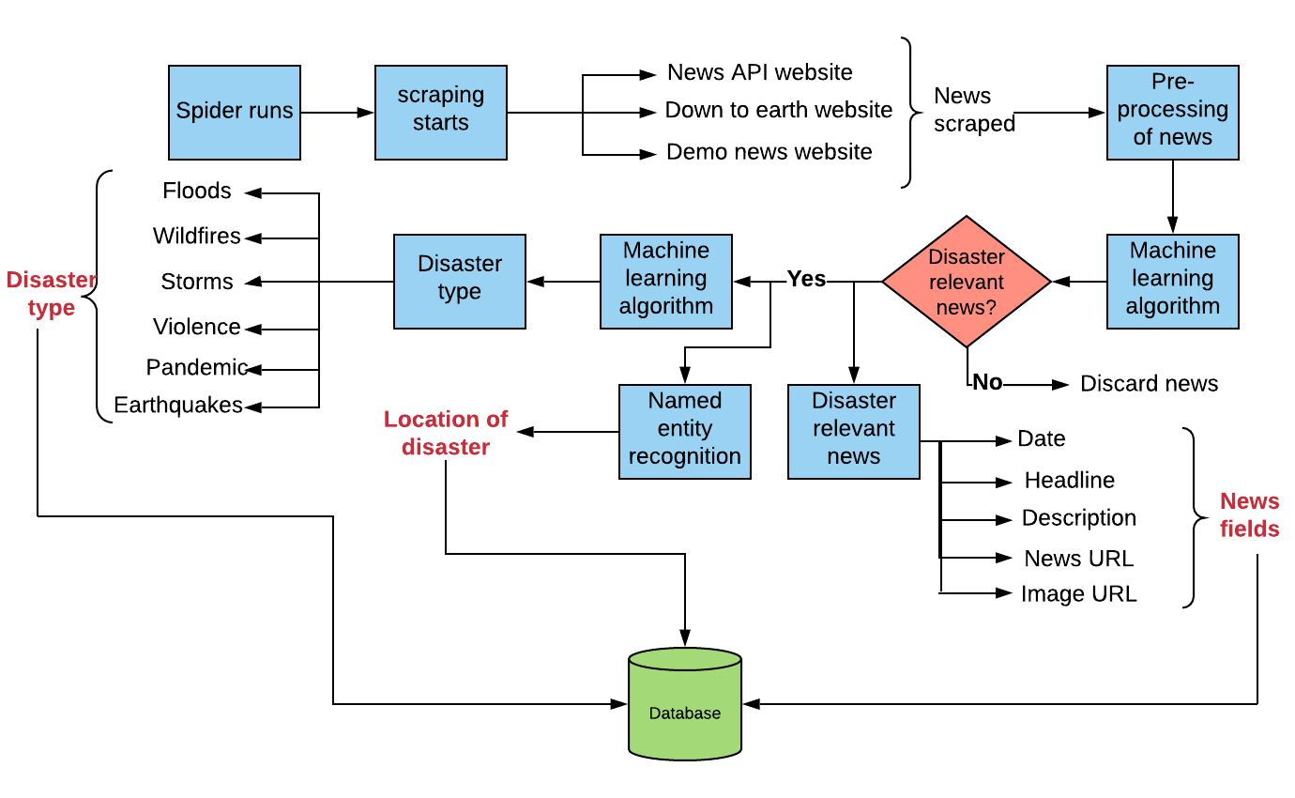

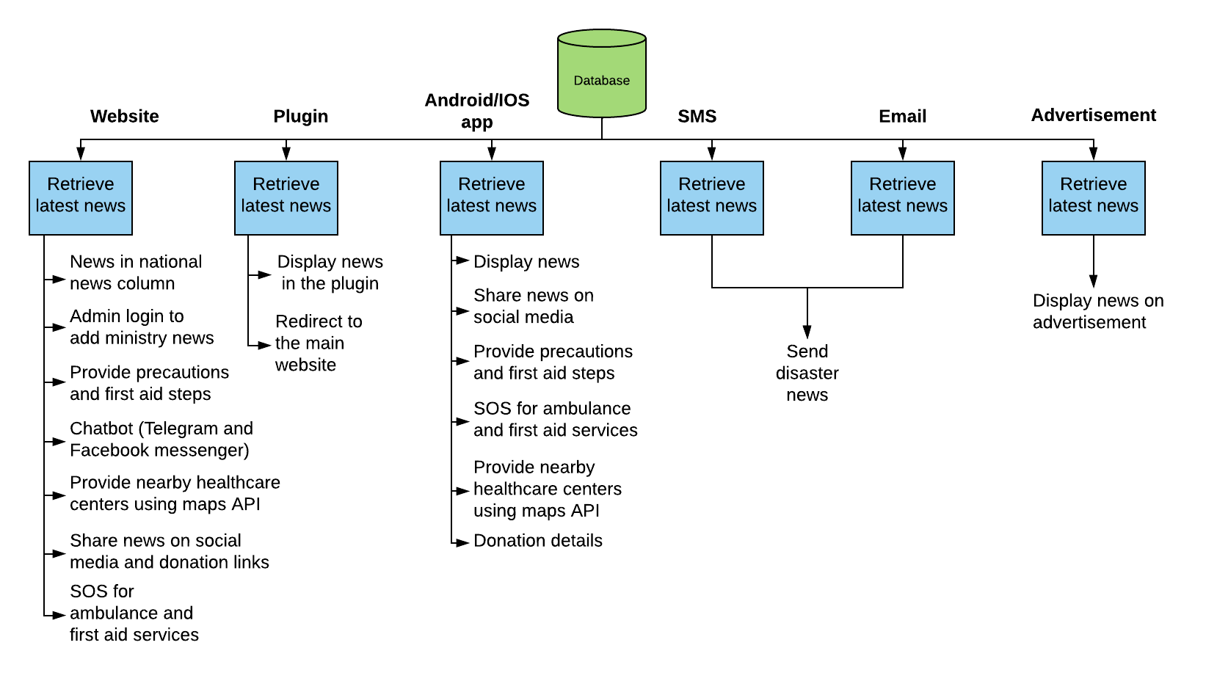

**Technologies used:**

1) Scraping:

* Python library requests
* Python library beautiful soup

2) Machine learning:

* Sci-kit learn
* spaCy

3) Front-end technologies:

* HTML5
* CSS3
* Js
* Bootstrap

4) Back-end technologies:

* Django

5) Mobile application:

* Flutter

**Platform used:**

1) Fast2sms for SMS

2) Django core mail utility for email

3) Firebase for database

4) Foursquare maps API

5) Google Places API

6) Dialogflow for chatbot

**Statistics:**

**Machine learning algorithm 1:**

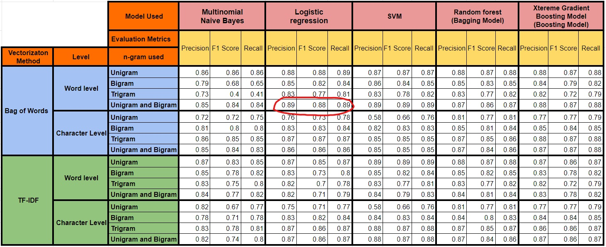

**Machine learning algorithm 2:**

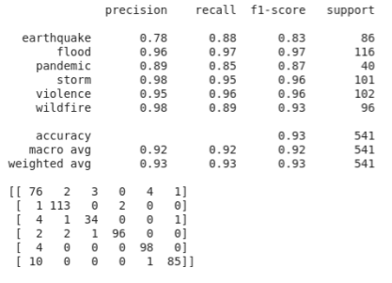

**Roadmap:**

Scraper:

1) Put on the scheduler so scrapes automatically and news stored in the database

Website:

1) Ministry personnel can add confidential data

2) Dynamically latest news is displayed

3) SOS for hospitals centres and NGO’s

4) Maps to view nearby healthcare centres

5) View first aid and precautionary steps

6) Get notified provision to receive SMS and email

7) Multilingual: provided in 15 different Indian languages.

Mobile app:

1) National(News all over India) and local news(personalized news based on Users location) displayed dynamically

2) SOS for hospitals centres and NGO’s

3) Maps to view nearby healthcare centres

4) View first aid and precautionary steps

5) Subscription provision to receive SMS and email

Plugin:

1) Dynamically display the latest news

Chatbot:

1) Provide first aid and precautionary steps

2) Connection to website, telegram and Facebook messenger

Advertisement:

1) Display ads on Facebook clone website with the news